Last updated: 07/22/2012; 20:00 PM

|  |
| --- |
| Department of Computer Science and Engineering | Team Itus |



Developed by:

Austin Miller

An Nguyen

Adrian Kotey

Jacky Trevino

Mark Madolora

|  |  |
| --- | --- |
| University of Texas at Arlington | NeverBLIND: The Hunter’s Failsafe  System Requirements Specification |

Table of Contents

Document Revision History 5

List of Figures 6

List of Tables 7

1 Product Concept 8

1.1 Purpose and Use 8

1.2 Intended Audience 8

2 Product Description and Functional Overview 8

2.1 Functions and Features 8

2.2 External Inputs and Outputs 8

2.3 Data Flow 9

2.4 Product Interfaces 9

3 Customer Requirements 9

3.1 Radio Frequency Strength 9

3.2 Aperture Adjustability 9

3.3 USB Rechargeable 10

4 Packaging Requirements 10

4.1 Emitter 10

4.2 Receiver Device 11

4.3 Hardware and Software Components 11

4.4 Maximum Dimensions 11

4.5 USB Charger 12

4.6 Manual and Quick Start Guide 12

5 Performance Requirements 12

5.1 Range 13

5.2 Response Time 13

5.3 Battery Life 13

5.4 Product Weight 14

5.5 Weather-Proofing 14

5.6 Output Jack 15

5.7 Interference Minimization 15

5.8 Indoor and Outdoor Usage 15

6 Safety Requirements 16

6.1 On/Off Switch 16

6.2 On/Off Indicator 16

6.3 Sharp Edges 17

6.4 Exposed Wiring 17

6.5 Wave Energy Emissions 17

6.6 Warning Label 18

7 Maintenance and Support Requirements 18

7.1 Code Documentation 18

7.2 Deliverables 19

7.3 Testing 19

8 Other Requirements 19

8.1 Notification Device 20

8.2 Cost Effective 20

8.3 Documents in American English 20

8.4 Measurements in Metric Units 21

8.5 Identifying Signal 21

9 Acceptance Criteria 21

9.1 Verify On/Off Switch 22

9.2 Verify NeverBLIND System Detects Friendly in Line of Sight under 400 ms 22

9.3 Verify NeverBLIND System Does not Notify User if Friendly is not in LOS 23

9.4 Verify that Product is Packaged with All Necessary Equipment 24

9.5 Verify that the Product is Safe to Use 24

10 Use Cases 25

10.1 User Points Weapon at Friendly 25

10.2 User Points Weapon at Non-Friendly 26

10.3 User Turns the NeverBLIND System On 27

10.4 User Turns the NeverBLIND System Off 28

11 Feasibility Assessment 29

11.1 Scope Analysis 29

11.2 Research 29

11.3 Technical Analysis 29

11.4 Cost Analysis 29

11.5 Resource Analysis 29

11.6 Schedule Analysis 29

12 Future Items 30

12.1 Performance Requirement 5.7 Interference Minimization 30

13 Glossary 30

# Document Revision History

|  |  |  |  |
| --- | --- | --- | --- |
| Revision # | Revision Date | Description | Rationale |
| 0.1 | 07/04/2012 | First Review Draft | Initial Internal Review |
| 0.2 | 07/15/2012 | Second Review Draft | Changes suggested by sponsor |
| 0.3 | 07/15/2012 | Future Items Added | Added Future Items |
| 0.4 | 07/15/2012 | Acceptance Criteria | Added Acceptance Criteria |
| 0.5 | 07/16/2012 | Third Review Draft | Changes suggested by team leader |
| 1.0 | 07/22/2012 | Fourth Review Draft | Changes suggested by TA |

# List of Figures

Figure 2‑1 Data Flow 9

Figure 10‑1 Use Case: User Points Weapon at Friendly 26

Figure 10‑2 Use Case: User Points Weapon at Non-Friendly 27

Figure 10‑3 Use Case: User Turns the NeverBLIND System On 28

Figure 10‑4 Use Case: User Turns the NeverBLIND System Off 29

# List of Tables

Table 2‑1 External Inputs and Outputs 9

Table 9‑1 Requirements Addressed by Acceptance Criteria 9.1 22

Table 9‑2 Requirements Addressed by Acceptance Criteria 9.2 22

Table 9‑3 Requirements Addressed by Acceptance Criteria 9.3 23

Table 9‑4 Requirements Addressed by Acceptance Criteria 9.4 24

Table 9‑5 Requirements Addressed by Acceptance Criteria 9.5 24

# Product Concept

This section describes the purpose, use, and intended user audience for the NeverBLIND System.

## Purpose and Use

The NeverBLIND System is intended to be a portable, weapon mountable product that will display a light when the weapon is pointed at a friendly. The product will be kept to the paintball domain. Our purpose is aimed at creating a product that would reduce friendly fire.

## Intended Audience

The intended audience of the NeverBLIND system is paintball players, who play on opposing teams. It is intended to help players differentiate between teammates and opponents.

# Product Description and Functional Overview

This section provides the reader with an overview of the NeverBLIND System. The primary operational feature of the NeverBLIND System is to notify the user through a blinking light that the weapon is pointed at a friendly target.

## Functions and Features

The NeverBLIND System will be an easy to deploy, weapon mountable system that can identify friendly targets by using a transmitter, receiver and notification device. All friendly personnel will be required to carry a transmitter, receiver and notification device with their weapon.

The NeverBLIND system will ensure that if a friendly target is in the LOS of the user’s weapon, the system will notify the user that a friendly is in the LOS until the target has moved out of the LOS of the weapon.

All subsystems, receiver, transmitter and notification device will be independent of one another.

## External Inputs and Outputs

|  |  |  |
| --- | --- | --- |
| Name | Description | Use |
| Transmitter | Will transmit a friendly signal. | Allows the receiver to identify/not identify a friendly target. |
| Receiver | Weapon mountable receiver that receives transmitter’s signal. | Allows the system to identify/not identify a friendly target. |
| Notification Device | Notification device that illuminates when a friendly target is detected. | Notifies the user that a friendly target has been detected by the device. |

Table 2‑1 External Inputs and Outputs

## Data Flow



Figure 2‑1 Data Flow

## Product Interfaces

The system will consist of basic on/off switches and lights to indicate when the product is active. There will also be a light that will indicate when the user is pointing the weapon at a friendly.

# Customer Requirements

## Signal Strength

### Description

The system will use a transmitter that easily penetrates vegetation but does not harm humans.

### Source

Sponsor

### Constraints

Market availability of transmitters/receivers that support such frequencies and their cost

### Standards

None

### Priority

1 – High

## Rechargeable

### Description

Each NeverBLIND System will be rechargeable.

### Source

Sponsor

### Constraints

Affordability of charging system and market availability

### Standard

None

### Priority

2 – Medium

# Packaging Requirements

This section describes the packaging requirements for the NeverBLIND System. Packaging requirements include all hardware and software components, including transmitter, receiver, charger, user manual and quick start guide.

## Transmitter

### Description

The transmitter sends a constant signal which the receiving device can pick up.

### Source

TeamItus

### Constraints

None

### Standards

None

### Priority

1 – High

## Receiver Device

### Description

The receiving device listens for a signal from the transmitter. When it picks up a signal from a friendly, it warns the user they are pointing at a friendly target.

### Source

TeamItus

### Constraints

None

### Standards

None

### Priority

1 – High

## Hardware and Software Components

### Description

The packaging will include all hardware and software components necessary to use the product.

### Source

TeamItus

### Constraints

None

### Standards

None

### Priority

1 – High

## Maximum Dimensions

### Description

The device shall not exceed the following dimensions: 5.08cm x 2.54cm x 7.62cm.

### Source

TeamItus

### Constraints

None

### Standards

None

### Priority

3 – Low

## Charger

### Description

A charger will be included with the system.

### Source

TeamItus

### Constraints

None

### Standards

None

### Priority

2 – Medium

## Manual and Quick Start Guide

### Description

A manual and Quick Start Guide will be included for the user, explaining how to use the NeverBLIND System.

### Source

TeamItus

### Constraints

None

### Standards

None

### Priority

2 – Medium

# Performance Requirements

This section describes the performance requirements for the NeverBLIND System. Performance requirements include range, response time, battery performance, radio frequency and adjustability.

## Range

### Description

The system will support a Line of Sight up to 300 meters. Each module of the NeverBLIND system will support notifying the shooter if a friendly is in the Line of Site if and only if the friendly is within 300 meters of the firing weapon.

### Source

Team Itus

### Constraints

Weather conditions, line of sight visibility and the system being in the “on” state

### Standards

None

### Priority

1 – High

## Response Time

### Description

The system shall be able to detect a friendly in its Line of Site in less than 400 milliseconds. This includes all RF travel time, detection processing, and output signal times.

### Source

Team Itus

### Constraints

Hardware and budget

### Standards

Human reaction time

### Priority

1 – High

## Battery Life

### Description

Each NeverBLIND module will have a battery life that lasts no less than 8 hours on a full battery charge upon its first use.

### Source

Team Itus

### Constraints

Hardware and budget

### Standards

None

### Priority

2 – Medium

## Product Weight

### Description

The system will be lightweight and will be less than 300 grams. This weight does not include the weight of the gun mount.

### Source

Sponsor

### Constraints

Hardware weight

### Standards

None

### Priority

2 – Medium

## Weather-Proofing

### Description

The system will be weather-proof within reasonable limits. Reasonable limits include sunny weather with clear skies, cloudy weather, and misty or foggy environments. Unreasonable weather includes rainy weather, tornadoes or hurricanes, and fires.

### Source

Team Itus

### Constraints

Casing Material

### Standards

None

### Priority

2 – Medium

## Output Jack

### Description

The system will provide an output jack so that 1st Party or 3rd party notification system can be plugged in. These can include, but are not limited to, buzzers and lights.

### Source

Team Itus

### Constraints

None

### Standards

None

### Priority

2 – Medium

## Interference Minimization

### Description

The system should minimize the effect of outside interference.

### Source

Team Itus

### Constraints

Casing material, signal strength and signal frequency

### Standards

None

### Priority

3 - Low

## Indoor and Outdoor Usage

### Description

The system should perform well indoors and outdoors.

### Source

Team Itus

### Constraints

None

### Standards

None

### Priority

3 – Low

# Safety Requirements

This section describes the safety requirements for the NeverBLIND System. Safety requirements include switches, packaging, wave emissions and warning labels.

## On/Off Switch

### Description

The NeverBLIND System will have a physical on/off switch where the user can turn their individual NeverBLIND modules on or off.

### Source

Team Itus

### Constraints

None

### Standard

None

### Priority

1 – High

## On/Off Indicator

### Description

The NeverBLIND System will have an on/off light indicator which will shine a green light when on, and not shine at all when off.

### Source

Team Itus

### Constraints

None

### Standard

None

### Priority

1 – High

## Sharp Edges

### Description

The NeverBLIND System will not have sharp or protruding edges that could be harmful to the user or its environment.

### Source

Team Itus

### Constraints

Casing material

### Standard

None

### Priority

1 – High

## Exposed Wiring

### Description

The NeverBLIND System will not have any exposed wiring. All wiring will either be enclosed or insulated.

### Source

Team Itus

### Constraints

None

### Standard

None

### Priority

1 – High

## Wave Energy Emissions

### Description

The system will use a frequency that can easily penetrate vegetation but not harm humans. This includes humans’ skin, organs, and/or bones.

### Source

Team Itus

### Constraints

None

### Standard

None

### Priority

2 – Medium

## Warning Label

### Description

The NeverBLIND System will have an attached warning label. The label will ensure that Team Itus, Mike O’Dell, Daniel Crane, or the University of Texas at Arlington are not liable for any injuries and/or deaths while using the NeverBLIND system. The Warning label will also specify that the system is not intended for use for persons less than the legal age to own and operate a weapon.

### Source

Team Itus

### Constraints

None

### Standard

None

### Priority

3 – Low

# Maintenance and Support Requirements

This section describes the maintenance and support requirements for the NeverBLIND System, which include USB rechargeable, code documentation and all other documents associated with the system.

## Code Documentation

### Description

The NeverBLIND System’s source code will be adequately documented so that a future development team with programming experience will be able to easily understand what the code is doing in order to enhance or debug it.

### Source

Team Itus

### Constraints

None

### Standard

None

### Priority

2 – Medium

## Deliverables

### Description

Upon completion of the system, Team Itus shall deliver all required milestone documents as made necessary by Mike O’Dell of the CSE Department at the University of Texas at Arlington’s Senior Design Course during the 2012 summer and fall semesters.

### Source

Team Itus

### Constraints

None

### Standard

None

### Priority

1 – High

## Testing

### Description

The NeverBLIND System will be thoroughly tested to ensure the production of the highest quality product.

### Source

Team Itus

### Constraints

None

### Standard

None

### Priority

1 – High

# Other Requirements

This section describes requirements for the NeverBLIND System that do not pertain to the previous categories, which include notification device, cost, documentation and measurement standard.

## Notification Device

### Description

The NeverBLIND System shall have an external line of sight output to indicate when the user is aiming their weapon at a human target.

### Source

Team Itus

### Constraints

None

### Standards

None

### Priority

1 – High

## Cost Effective

### Description

The system should be cost effective. The price will be less than $25 US dollars.

### Source

Team Itus

### Constraints

Cost of components

### Standards

None

### Priority

2 – Medium

## Documents in American English

### Description

All documents delivered by Team Itus will be in American English Language.

### Source

Team Itus

### Constraints

None

### Standards

None

### Priority

2 – Medium

## Measurements in Metric Units

### Description

All measurements will be made in metric units.

### Source

Team Itus

### Constraints

None

### Standards

None

### Priority

2 – Medium

## Identifying Signal

### Description

The NeverBLIND System will have a standard protocol for all signals transmitted from the device.

### Source

Team Itus

### Constraints

None

### Standards

None

### Priority

2 – Medium

# Acceptance Criteria

This section describes the acceptance criteria for the NeverBLIND System. Based on the following criteria the sponsor will determine if the product’s requirements are complete or incomplete.

## Verify On/Off Switch

### Requirements Addressed

|  |  |  |
| --- | --- | --- |
| Requirement | Name | Description |
| 6.1 | On / Off Switch | The NeverBLIND System will have a physical on/off switch where the user can turn their individual NeverBLIND modules on or off. |
| 6.2 | On / Off Indicator | The NeverBLIND System will have an on/off light indicator which will shine a green light when on, and not shine at all when off. |

Table 9‑1 Requirements Addressed by Acceptance Criteria 9.1

### Verification Procedure

The NeverBLIND System will initially be in the off state. The user will first verify that the on/off indicator is not lit. The user will then turn the NeverBLIND system on, by placing the on/off switch in the on position and verify that the on/off indicator is lit. The user will then return the on/off switch to the off position and verify that the on/off indicator is no longer lit.

## Verify NeverBLIND System Detects Friendly in Line of Sight under 400 ms

### Requirements Addressed

|  |  |  |
| --- | --- | --- |
| Requirement | Name | Description |
| 3.1 | Radio Frequency Strength | The system will use a Radio Frequency that easily penetrates vegetation but does not harm humans. |
| 4.1 | Transmitter | The transmitter sends a constant signal which the receiving device can pick up. |
| 4.2 | Receiver Device | The receiving device listens for a signal from the emitter. When it picks up a signal from a friendly, it warns the user they are pointing at a friendly target. |
| 5.1 | Range | The system will support a Line of Sight up to 300 meters. Each module of the NeverBLIND system will support notifying the shooter if a friendly is in the Line of Site if and only if the friendly is within 300 meters of the firing weapon. |
| 5.2 | Response Time | The system shall be able to detect a friendly in its Line of Site in less than 400 milliseconds. This includes all RF travel time, detection processing, and output signal times. |
| 8.1 | Notification Device | The NeverBLIND System shall have an external line of sight output to indicate when the user is aiming their weapon at a human target. |
| 8.5 | Identifying Signal | The NeverBLIND System will have a standard protocol for all signals emitted from the device. |

Table 9‑2 Requirements Addressed by Acceptance Criteria 9.2

### Verification Procedure

The NeverBLIND System will be turned on. The user will then point the weapon at a friendly within 1000 meters. The user will then verify that the NeverBLIND system has identified a friendly by checking to make sure the notification light is illuminated.

## Verify NeverBLIND System Does not Notify User if Friendly is not in LOS

### Requirements Addressed

|  |  |  |
| --- | --- | --- |
| Requirement | Name | Description |
| 3.1 | Radio Frequency Strength | The system will use a Radio Frequency that easily penetrates vegetation but does not harm humans. |
| 3.2 | Aperture Adjustability | The NeverBLIND System will have an on/off light indicator which will shine a green light when on, and not shine at all when off. |
| 4.1 | Emitter | The emitter sends a constant signal which the receiving device can pick up. |
| 4.2 | Receiver Device | The receiving device listens for a signal from the emitter. When it picks up a signal from a friendly, it warns the user they are pointing at a friendly target. |
| 5.1 | Range | The system will support a Line of Sight up to 1000 meters. Each module of the NeverBLIND system will support notifying the shooter if a friendly is in the Line of Site if and only if the friendly is within 1000 meters of the firing weapon. |
| 5.2 | Response Time | The system shall be able to detect a friendly in its Line of Site in less than 400 milliseconds. This includes all RF travel time, detection processing, and output signal times. |
| 8.1 | Notification Device | The NeverBLIND System shall have an external line of sight output to indicate when the user is aiming their weapon at a human target. |
| 8.5 | Identifying Signal | The NeverBLIND System will have a standard protocol for all signals emitted from the device. |

Table 9‑3 Requirements Addressed by Acceptance Criteria 9.3

### Verification Procedure

The NeverBLIND System will be turned on. The user will point the weapon into an open area where there are no friendlies present. The user will then verify that the NeverBLIND System has not detected a friendly by checking to make sure the notification light is not illuminated.

## Verify that Product is Packaged with All Necessary Equipment

### Requirements Addressed

|  |  |  |
| --- | --- | --- |
| Requirement | Name | Description |
| 4.1 | Emitter | The emitter sends a constant signal which the receiving device can pick up. |
| 4.2 | Receiver Device | The receiving device listens for a signal from the emitter. When it picks up a signal from a friendly, it warns the user they are pointing at a friendly target. |
| 4.3 | Hardware and Software Components | The packaging will include all hardware and software components necessary to use the product. |
| 4.5 | USB Charger | A USB charger will be included with the system. |
| 4.6 | Manual and Quick Start Guide | A manual and Quick Start Guide will be included for the user, explaining how to use the NeverBLIND System. |
| 7.2 | Deliverables | Upon completion of the system, Team Itus shall deliver all required milestone documents as made necessary by Mike O’Dell of the CSE Department at the University of Texas at Arlington’s Senior Design Course during the 2012 Summer and Fall semesters. |

Table 9‑4 Requirements Addressed by Acceptance Criteria 9.4

### Verification Procedure

The user will visually verify that all necessary equipment is included in the product package. Team Itus will ensure that all components are in working condition.

## Verify that the Product is Safe to Use

### Requirements Addressed

|  |  |  |
| --- | --- | --- |
| Requirement | Name | Description |
| 4.6 | Manual and Quick Start Guide | A manual and Quick Start Guide will be included for the user, explaining how to use the NeverBLIND System. |
| 6.3 | Sharp Edges | The NeverBLIND System will not have sharp or protruding edges that could be harmful to the user or its environment. |
| 6.4 | Exposed Wiring | The NeverBLIND System will not have any exposed wiring. All wiring will either be enclosed or insulated. |
| 6.5 | Wave Energy Emissions | The system will use a frequency that can easily penetrate vegetation but not harm humans. This includes humans’ skin, organs, and/or bones. |
| 6.6 | Warning Label | The NeverBLIND System will have an attached warning label. The label will ensure that Team Itus, Mike O’dell, Daniel Crane, or the University of Texas at Arlington are not liable for any injuries and/or deaths while using the NeverBLIND system. The Warning label will also specify that the system is not intended for use for persons less than the legal age to own and operate a weapon. |
| 8.3 | Documents in American English | All documents delivered by Team Itus will be in American English Language. |

Table 9‑5 Requirements Addressed by Acceptance Criteria 9.5

### Verification Procedure

The user will visually inspect the NeverBLIND System to ensure that the product casing will not cause damage or harm to the user. The user will then verify that all documentation provides clear and understandable instructions and warnings. The user will then physically use the NeverBLIND System to ensure that the product is safe to use.

# Use Cases

Use cases are used to show how the user will interact with the NeverBLIND System. Each use case will contain a brief description of the scenario, the actor(s) involved and a UML diagram depicting the use case.” TUCBW” will be used in place of “The Use Case Begins With” and “TUCEW” will be used in place of “The Use Case Ends With”.

## User Points Weapon at Friendly

### Scenario

The user points his weapon at a friendly. The friendly’s transmitter will emit a signal that it is a friendly. The weapon will receive the transmission and signal the user with a blinking light that the target is a friendly.

### Actor(s)

User and Friendly

### TUCBW

The user points his weapon at a friendly.

### TUCEW

The weapon displays a blinking light.

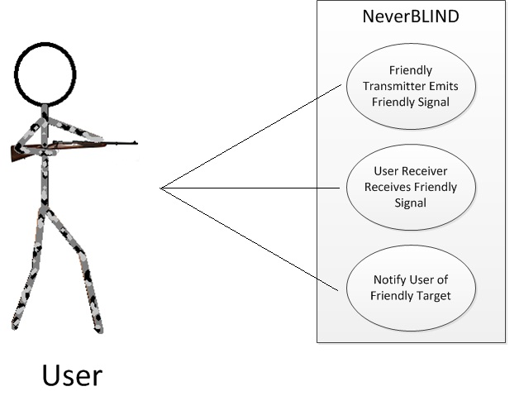

Figure 10‑1 Use Case: User Points Weapon at Friendly

## User Points Weapon at Non-Friendly

### Scenario

The user points his weapon at a non-friendly who will not be transmitting a friendly signal. The weapon will not display a blinking light and the user will be allowed to fire.

### Actor(s)

User and Non-Friendly

### TUCBW

The user points his weapon at a Non-Friendly.

### TUCEW

The weapon will not display a blinking light.

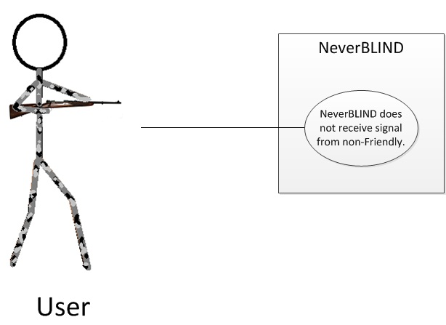

Figure 10‑2 Use Case: User Points Weapon at Non-Friendly

## User Turns the NeverBLIND System On

### Scenario

The user turns the NeverBLIND System on. The NeverBLIND system illuminates the on/off light to acknowledge it has been turned on.

### Actor(s)

User

### TUCBW

The user turns the NeverBLIND System on.

### TUCEW

The NeverBLIND System will display the on/off light.

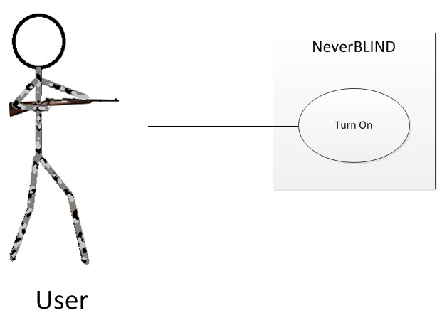

Figure 10‑3 Use Case: User Turns the NeverBLIND System On

## User Turns the NeverBLIND System Off

### Scenario

The user turns the NeverBLIND System off. The NeverBLIND system dims the on/off light to acknowledge it has been turned off.

### Actor(s)

User

### TUCBW

The user turns the NeverBLIND System off.

### TUCEW

The NeverBLIND System will dim the on/off light.

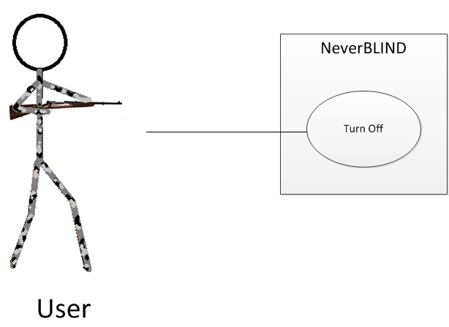

Figure 10‑4 Use Case: User Turns the NeverBLIND System Off

# Feasibility Assessment

The purpose of this section is to assess the feasibility of the NeverBLIND System. The feasibility in this section and of the project is based on preliminary research, as done by Team Itus and past projects that were similar to that of Team Itus’. In summary, the NeverBLIND System (with requirements identified as critical) is feasible and can be completed by Team Itus by December of 2012.

## Scope Analysis

The scope of the work to be completed by December 2012 is those requirements labeled as “Critical”. Such requirements are reasonable within the time schedule provided, the skills of Team Itus’ team members, and necessary to complete a minimum product. All other requirements fall under categories high, medium or low and will be processed in the order high, medium and low where all high must be completed before moving to the next category and so forth. Lastly, future requirements will not be added during any phase after the Baseline System Requirements specification is finalized; this is to mitigate the risk of feature creep. Any future requirements or ideas will be put on a list for documentation and will be provided for any other team that might continue work on the NeverBLIND System.

## Research

Research done for the NeverBLIND System falls into three groups:

1. Previous related projects
2. Hardware research
3. Military IFF system research

Previous projects such as UFO, DANGR Squad and PAINTek were referenced for scheduling and documentation. It is likely that during other phases of development they will be referenced for other things like designs.

Hardware research was done in order to see if such parts for a personal IFF System were on the market and within budget. It was then determined whether or not this hardware would meet the requirements. Modules were found such that they met requirements, were within budget, and are available for purchase by civilians.

Lastly, the idea of an IFF System was researched. It is known that the military currently uses IFF Systems on planes but on for ground troops. Detection methods, encryption, and the general idea were based on this research. A personal IFF System, even more so for the hunting domain, has already been conceptualized and patented, however the method of design planned by Team Itus will differ from <http://www.faqs.org/patents/app/20120073178#b> , and thus will not interfere with such patent.

## Technical Analysis

There are 3 main components to the IFF System:

1. A hardware solution so that there exist broadcasters and receivers to detect each other and inform a user whether or not they are pointing at a friendly target
2. A software solution that can process data given by such hardware solution and make it useful to the end user
3. Methods of detection

## Cost Analysis

Team Itus NeverBLIND System was designed so that the total cost of all components falls within the budget of $800 US American Dollars. To make the solution marketable and as cost effective as possible the cost will try to be minimized as much as possible while still ensuring all requirements are met.

Costs assumptions are as follows:

|  |  |  |
| --- | --- | --- |
| Component | Low End Cost | High End Cost |
| XBee-Pro DigiMesh 900 Development Kit w/4 | $300 | $300 |
| [XBee-PRO DigiMesh 900 Extended Range Module w/ Wire Antenna](http://store.digi.com/index.cfm?fuseaction=product.display&Product_ID=1241) | $39 | $39 |
| Plastic Covering for Wireless Modules | $20 | $40 |
| Velcro for Module Receiver Mounting | $5 | $15 |
| Belt for Emitter Mounting | $10 | $15 |
| Paintball Gun | $0 | $150 |
| Shipping | $20 | $60 |
| Totals | $394 | $619 |

Table 11‑1 Cost Assumptions

In both high and low end cost analysis the IFF System Project falls within budget and does not Trigger the low budget risk. Cost wise the IFF System is feasible.

## Resource Analysis

Team Itus is composed of three Undergraduates of Computer Science (An Nyguyen, Jacky Trevino, and Mark Madolora), one Undergraduate of Computer Hardware Engineering (Adrian Kotey) and one Undergraduate of Software Engineering (Austin Miller). All tasks will be divided among these members.

Team Itus’ strengths include documentation, scheduling, and software. Madolora is especially refined in using products such as Microsoft Office, while accompanied by those skills of Trevino and Miller, documentation should be easy with a professional product at the end of Phase 1. Team Itus is exceptional in scheduling, all members are punctual and are goal-oriented to stay on task and meet deliverable timelines. Software is another strong suit of Team Itus; they are strong in areas such as Java and C++.

Team Itus’ weaknesses include familiarity with third-party applications and minimal specialty with tools and hardware. Although Team Itus is well versed in office applications created by Microsoft, Team Itus is less familiar with applications referenced in the team assesment sheet, such as SourceSafe and XDB. Another area of risk is hardware. Kotey is Team Itus’ only expert on computer hardware. In order to mitigate the risk exposure of Kotey’s absence, Nguyen will double on hardware.

## Schedule Analysis

Team Itus has used three methods of time estimation to create a feasible schedule that can ensure all “High” level requirements are met, and that they can be completed by December 2012. Using Function Points, the COCOMO Model, and Jones First Order Estimation the size and effort of the project can be estimated to determine the feasibility of the schedule created.

### Size Estimates

|  |  |  |  |  |
| --- | --- | --- | --- | --- |
| Program Characteristic | Low Complexity | Moderate Complexity | High Complexity | Function Point Totals |
| Number of Inputs | 2*3 | 1*4 | 0*6 | 10 |
| Number of outputs | 2*4 | 0*8 | 1*7 | 15 |
| Inquiries | 2*3 | 1*4 | 0*6 | 10 |
| Logical Internal files | 0*7 | 2*10 | 0*15 | 20 |
| External interface files | 0*5 | 0*7 | 0*10 | 0 |
| Unadjusted Function Points (UAF)Total | | | | 55 |
| Adjustment Factor | | | | 1.0 |
| Total | | | | 55 |

Using McConnell’s (Reference?) to calculate Effort (using Systems Kind of Software)

|  |  |
| --- | --- |
| Jones’ First Order Estimate Influence Multipliers | |
| Category | Influence ( 1- 5) |
| Data Communication | 5 |
| Distributed Data Processing | 1 |
| Performance | 3 |
| Heavily Used Configuration | 2 |
| Transaction Rate | 3 |
| Online Data Entry | 1 |
| End-User Efficiency | 1 |
| Online Update | 1 |
| Complex Processing | 2 |
| Re-usability | 3 |
| Installation Ease | 5 |
| Operational Ease | 5 |
| Multiple Site | 2 |
| Facilitate Change | 1 |
| Total | 35 |

Value Adjustment Factor = VAF = ( .65 + ( .01 * 35 ) ) = 1.0

Adjusted Function Point = AFP = UAF * VAF = 55 * 1.0 = 55

### Effort Estimation

Using McConnell’s Table 8-7 to calculate Effort by Jones’ First Order Estimation (using Systems Kind of Software).

|  |  |  |
| --- | --- | --- |
| Worst In Class | Average | Best in Class |
| 55.48 | 55.45 | 55.43 |
| 6.84 Calendar Months | 6.07 Calendar Months | 5.6 Calendar Months |
| 11.85 Man Months | 8.28 Man Months | 6.50 Man Months |
| 2.37 Calendar Months | 1.66 Calendar Months | 1.30 Calendar Months |

Based on function point analysis, it is shown that in the worst case it will take approximately 2 ½ calendar months to complete the NeverBLIND System, while the best case it will take 1 ½ months to complete the NeverBLIND System. Thus the project should be more than feasible schedule-wise.

### COCOMO Model

[TODO]

# Future Items

This section will elaborate on items that were given a low priority and may not be in the deliverable prototype due to constraints.

## Performance Requirement 5.7 Interference Minimization

### Requirement Description

The system should minimize the effect of outside interference.

### Constraints

Minimizing interference requires knowledge of signal processing and interference rejection that no one in our group already possesses. Team Itus may not have sufficient time to learn and implement interference minimization and it is not critical to the performance of this system.

# Glossary

|  |  |
| --- | --- |
| Term | Defintion |
| IFF | Identification Friend or Foe |
| TUCBW | The Use Case Begins With |
| TUCEW | The Use Case Ends With |
| RF | Radio Frequency |
| LOS | Line of Sight |